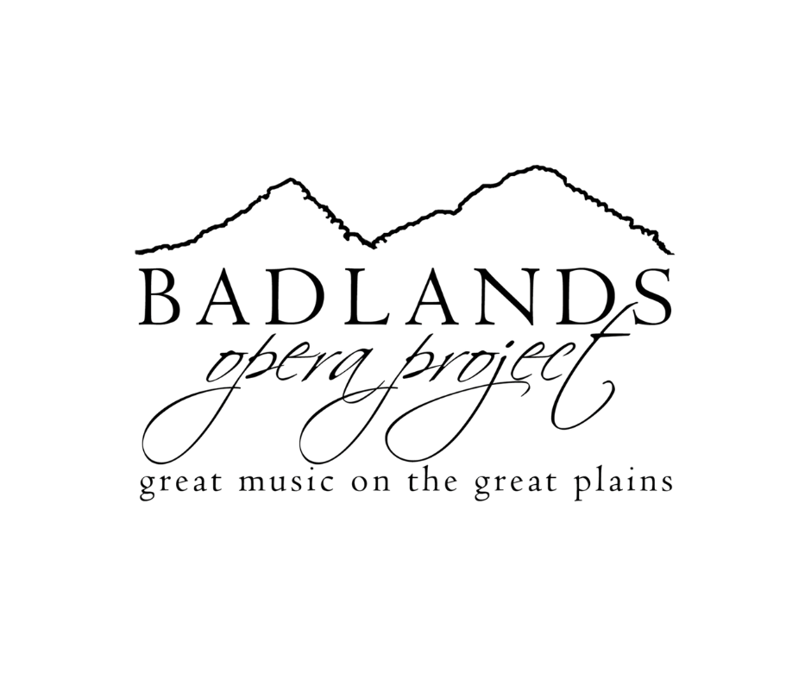
Summer Camp Information

Camp Dates | June 7-13, 2026
** Auditions will be held Sunday, April 12, 2026 from 2:00-5:00 pm at DSU **
Location | Dickinson State University May Hall, Stickney Auditorium
Ages | students ages 8-19 years old.
Times | Camp days will run from 12:30-8:30 PM
Tuition
$375 | Early Bird (by March 15)
$450 | Regular (by March 31)
$500 | Late (by April 12)
Tuition includes:
- Instruction for Camp Week
- 1 Private Voice Lesson
- 2 Performances with Costuming
- Script (to keep)
- Digital Music
- 2 Complimentary Tickets per performer
- Badlands Opera Apparel
- Pre-Show Opening Act for the 2026 Medora Musical!
- Snacks and Select Evening Meals
A $100 deposit will be invoiced to you after registration. The remaining tuition will be invoiced after auditions on Sunday, April 12, 2026.
Scholarships & Fundraising Update
In previous years, Badlands Opera Summer Camp offered a volunteer point system that allowed families to earn tuition discounts. This year, we’ve simplified our model to make registration more accessible and flexible for everyone.
Instead of volunteer points, we have lowered tuition across all registration tiers:
- Early Bird tuition reduced by $75
- Regular and Late registration reduced by $50
In addition, we are offering the option to set up an individual camper fundraising page through GiveButter. Fundraising allows our available scholarship funds to stretch further and helps us support as many campers as possible.
Participation in fundraising is optional, and scholarship assistance is available but limited. Families in need of additional support are encouraged to apply early.
Cancellations
Cancellation will result in a $100 non-refundable fee after April 1st, 2026.
Communication
During the rehearsal process, it is important to create an atmosphere free of unnecessary distractions so campers can fully focus on learning, creating, and collaborating. Campers who bring cell phones will be asked to turn them in at daily check-in. Phones may be checked out during breaks. This policy also encourages campers to build meaningful, face-to-face relationships with one another.
All camp announcements, schedule updates, media files, and general communication will be shared through GroupMe. Parents and/or students are encouraged to join the group to stay up-to-date leading up to and throughout the week of camp.
Join the GroupMe here:
https://groupme.com/join_group/112463839/DeTnBzPl
Before the Camp Week
After casting is announced, performers will have a few weeks to memorize the script and songs.
Memorization has to be done in advance at home! Camp Week will be spent polishing and putting it all together.
Materials
You will receive a script book and access to digital accompaniment tracks (instruments only) and vocal tracks (vocal demos) of each song.
Students will need to bring:
- scripts (can be marked in, highlighted, etc.)
- pencil
- water bottle
- black pants/leggings & a solid black t-shirt
- Females- tan or black flats, OR ballet shoes, OR tan or black character shoes. BOP has limited sizes available to borrow.
- Male- black jazz shoes OR black dress shoes. BOP has limited sizes available to borrow.
- Students should wear clothing that is comfortable and easy to move in.
Costumes
This year, many costumes will be provided by the Dickinson State University Theatre Department. In addition, select costume pieces will be purchased for campers to keep as part of their performance experience.
Performances
We have 2 performances scheduled for Saturday, June 13th at 2pm and 7pm. The performances will be in the Dickinson State University Stickney Auditorium.
Tickets & Performances
Each student will receive two complimentary tickets to be used for either performance. Families will be provided with a code to reserve these tickets online through our ticketing platform at www.badlandsopera.org.
Additional tickets may be purchased in advance online or at the door. Please note that ticket prices increase at the door.
Advance Ticket Prices:
- Preschool & younger: $5
- Students (K–12): $10
- Adults: $15
Ticket sales will begin 45 minutes prior to showtime, with doors opening 30 minutes before the performance.
Both performances are open to the public.
Contact Information
If you have questions regarding the camp, auditions or any matters regarding the production, please
feel free to contact us via email at contact@badlandsopera.org
Badlands Opera Project PO Box 945, Dickinson, ND 58602
- Kelsey Rogers, Artistic Director
- Kayla Kilwein, Executive Director
- Sonja Tinjum, President
- Jesse Kilwein, Vice President
- Jill Rae, Treasurer
- Beth Hurt, Board Member
- Cole Beck, Social Media
- Rob Eilts, Board Member
- Keira Rambousek, Human Relations
- Dan Parke, Board Member
- Karli Paluck, Marketing
- Daniel Paluck, Marketing
- Karen Wagner, Board Member

