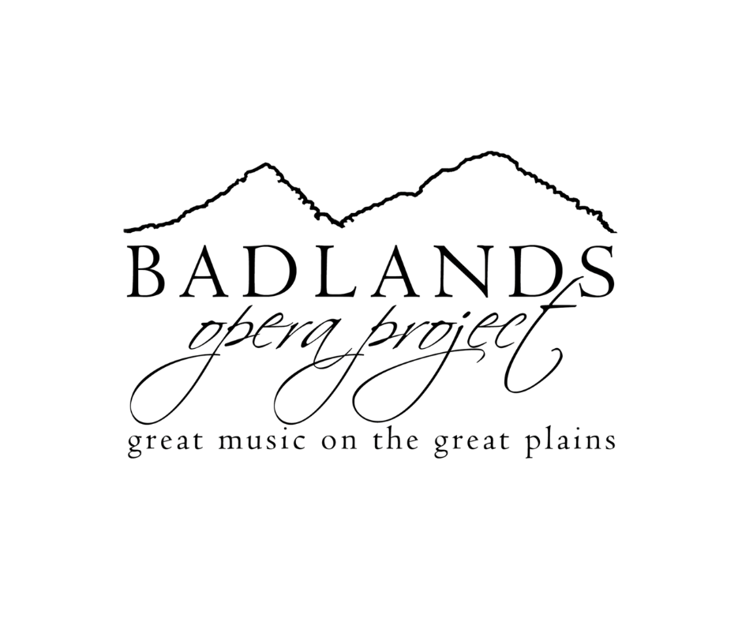
Audition Information

Auditions will be held Sunday, April 12, 2025 from 2:00-5:00 pm. The auditions will be held at Dickinson State University | May Hall | Stickney Auditorium - Dance Studio.

The auditions will be individual, with only one student at a time in front of an audition panel of 2-4 people. This is a casual audition of approximately 15 minutes and will be done in a non-intimidating manner. In addition to your 15-minute audition, your child's headshot photo and costume measurements will be taken at the audition.

**If you are unable to attend auditions, you may submit a video of the audition song, along with a recent photo, and costume measurements.

Just relax and be yourself, then show us how you can “become” your character. The auditions will be recorded so that we can review them again later as we make casting decisions.

Characters:

ERIC is a student at school with Matilda and has the very first solo line of the entire show. He also has some featured moments as one of Matilda's schoolmates. It's helpful if Eric is also an expressive actor.

Vocal Audition: "When I Grow Up"

AMANDA is a student at school with Matilda. She has a few solos and lines, but her most featured moment is when Trunchbull throws her through the air using her pigtails. She is a strong singer and mover.

Vocal Audition: "When I Grow Up"

BRUCE is one of Matilda's schoolmates and has the bad luck to get caught after eating Trunchbull's cake. Bruce goes through quite a transformation throughout the show and has some important solos.

Vocal Audition: "Revolting Children"

ALICE and TOMMY are classmates of Matilda who each sin solos, and HORTENSIA has a few lines spoken in rhythm.

Vocal Audition: "When I Grow Up"

LAVENDER is one of the kids at school with Matilda. She is kind and bright (though not as brilliant as Matilda_ and quickly decides that Matilda is her best friend.

Vocal Audition: "Miracle"

NIGEL goes to school with Matilda. He is enthusiastic, sweet, and always in a bit of a panic. Nigel has a few solos and some great featured moments in the show.

Vocal Audition: "School Song"

MATILDA WORMWOOD is the hero of the show. She's brilliant, resilient, creative, and kind, despite growing up in difficult circumstances. Her parents treat her poorly, but Matilda escapes into a world of books, which puts her reading level far above the other children in her class. She also develops a bit of magical power in an effort to defeat Trunchbull.

Vocal Audition: "Naughty"

MR. WORMWOOD is Matilda's father. He is egotistical, rude, and not very bright, not to mention a liar. Though Mr. Wormwood is not a good person and he is mean to Matilda, his harebrained schemes can be hilariously funny.

MRS. WORMWOOD is Matilda's mother. Like her husband, she dislikes Matilda and does not understand why her daughter loves to read. Mrs. Wormwood is selfish, obsessed with her own appearance, and believes everything she sees on TV. Her dancing lessons with Rudolpho are the most important part of her day.

MICHAEL is Matilda's brother. He is not very bright, though he is the apple of his father's eye. This is a hilarious supporting role.

MRS. PHELPS is the kindly librarian who loves hearing Matilda's stories.

ESCAPOLOGIST is a character of Matilda's creation. Everything this character does is grand and exaggerated. This featured role is a solid actor and mover.

Vocal Audition: "Acrobat Story (Part 1)"

ACROBAT, like the Escapologist, is a product of Matilda's imagination.

Vocal Audition: "Acrobat Story (Part 1)"

MISS HONEY is a teacher at Matilda's school. She is kind, is generous, and really cares about the children despite her own desperate circumstances.

Vocal Audition: "This Little Girl"

AGATHA TRUNCHBULL is the quintessential terrifying tyrant. As headmistress, she runs her school like a dictator, making up arbitrary rules to suit her every whim and dreaming up creative punishments. The Trunchbull can be played by a male or female (though the character is female).

Vocal Audition: "The Hammer"

RUDOLPHO is Mrs. Wormwood's self-obsessed dance teacher. This is a hilarious featured role for a comedic performer who moves well.

SERGEI has been swindled by Mr. Wormwood. Though he shows up looking for payback, Matilda has had quite enough of revenge, and Sergei lets the Wormwoods escape.

RUSSIANS, LITTLE KIDS, BIG KIDS (including BIG KID 1, BIG KID 2, and BIG KID 3), KIDS, MUMS, DADS, the COOK, and the MECHANIC

**Vocal Scores, accompaniments, and other audition material will be made available at a later date via GroupMe**

Casting

The auditions are designed to place you in roles that are most suited for you, where you can grow as performers and develop your theatre skills. This is a large cast production, and there is something for everyone—both beginners and veterans alike. Everyone will be a part of the production!

Casting is usually done within a week and will be announced via GroupMe. Once you know what character(s) you’ll be portraying, start memorizing your lines and songs! Memorization is only the first basic step—and that must be done as quickly as possible so that you can start working on expression and characterization.

What Role Will I Get?!

Please be aware that you will be expected to take the role to which you are assigned and perform it to the best of your ability—whatever it is. Casting decisions are made based on several factors, including audition performance, past experience, maturity, cooperation level, and how well they “fit” both the roles and the cast as a whole. There will be many students who excel at the above criteria and who could excel at any given role.

Remember this is a performing arts camp—you are auditioning with other strong performers. We will have to make tough decisions based on small details. This is part of the learning process. As tough as it seems here, it’s even tougher out there! Learning to take any role and make it your best is a learned skill for both on stage and off. Those that succeed have mastered that skill. We guarantee that everyone who participates in this production will gain valuable experience and will at least have the opportunity to learn! We don’t want to see anyone pull out due to casting— you either want to be in the show or not—please decide before you audition.

Just a note of caution: it always affects your next audition when you pull out of a show, not just with Badlands Opera Project, but at any theatre or performance company!

